# Lab: Lambda and LINQ

Problems for exercises and homework for the [“Programming Fundamentals” course @ SoftUni](https://softuni.bg/courses/programming-fundamentals).

Check your solutions here: <https://judge.softuni.bg/Contests/174/Dictionaries-Lambda-and-LINQ-Lab>.

# LINQ

## Sum, Min, Max, Average

Write a program to read **n** integers and print their **sum**, **min**, **max**, **first**, **last** and **average** values.

### Examples

|  |  |
| --- | --- |
| **Input** | **Output** |
| **5**  12  20  -5  37  8 | Sum = 72  Min = -5  Max = 37  Average = 14.4 |
| **4**  50  20  25  40 | Sum = 135  Min = 20  Max = 50  Average = 33.75 |

### Hints

* Include the “System.Linq” namespace to enable aggregate functions.
* Read the input array nums[].
* Use nums.Min(), nums.Max(), etc.

## Largest 3 Numbers

Read a **list of real numbers** and **print largest 3 of them**. If less than 3 numbers exit, print all of them.

### Examples

|  |  |  |  |  |
| --- | --- | --- | --- | --- |
| **Input** | **Output** |  | **Input** | **Output** |
| 10 30 15 20 50 5 | 50 30 20 | 20 30 | 30 20 |

### Hints

You can use LINQ query like this: nums.OrderByDescending(x => x).Take(3).

## Short Words Sorted

Read a **text**, extract its **words**, find all **short words** (less than 5 characters) and print them **alphabetically**, in **lowercase**.

* Use the following separators: . , : ; ( ) [ ] " ' \ / ! ? *(space)*.
* Use case-insensitive matching.
* Remove duplicated words.

### Examples

|  |  |
| --- | --- |
| **Input** | **Output** |
| In SoftUni you can study Java, C#, PHP and JavaScript. JAVA and c# developers graduate in 2-3 years. Go in! | 2-3, and, c#, can, go, in, java, php, you |

### Hints

* To extract the words from the input text, **split** by the specified separators.
* Use a **LINQ expression**:
  + Filter by word length: Where(…)
  + Order by word: OrderBy(…)
  + Use **distinct** to avoid repeated words: Distinct().

## Fold and Sum

Read an array of **4*k integers**, **fold** it like shown below, and **print the sum** of the upper and lower rows (**2*k integers**):

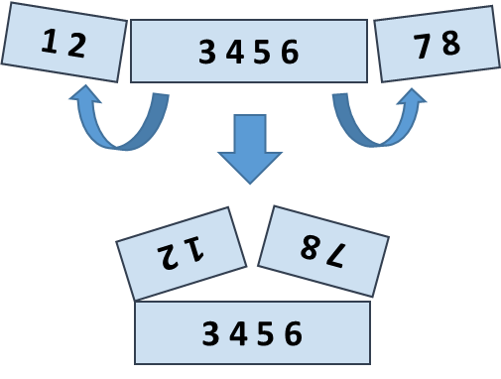

### Examples

|  |  |  |
| --- | --- | --- |
| **Input** | **Output** | **Comments** |
| 5 **2 3** 6 | 7 9 | 5 6 +  2 3 =  7 9 |
| 1 2 **3 4 5 6** 7 8 | 5 5 13 13 | 2 1 8 7 +  3 4 5 6 =  5 5 13 13 |
| 4 3 -1 **2 5 0 1 9 8** 6 7 -2 | 1 8 4 -1 16 14 | -1 3 4 -2 7 6 +  2 5 0 1 9 8 =  1 8 4 -1 16 14 |

Hints

Use a **LINQ expression**:

* Row 1, left part: take the **first** k numbers and **reverse**.
* Row 1, right part: **reverse** and take the **first** k numbers.
* **Concatenate** the **left** and the **right** part of row 1.
* Row 2: skip the **first k** numbers and take the next **2*k** numbers.
* Sum the arrays row1 and row2: var sum = row1.Select((x, index) => x + row2[index]).